Capstone Project – Social Media Tourism

Problem Statement:
An aviation company that provides domestic as well as international trips to the customers now wants to apply a targeted approach instead of reaching out to each of the customers. This time they want to do it digitally instead of tele calling. Hence they have collaborated with a social networking platform, so they can learn the digital and social behavior of the customers and provide the digital advertisement on the user page of the targeted customers who have a high propensity to take up the product.
Propensity of buying tickets is different for different login devices. Hence, you have to create 2 models separately for Laptop and Mobile. [Anything which is not a laptop can be considered as mobile phone usage.]
Note: The advertisements on the digital platform are bit expensive, hence you need to be very accurate while creating the models.

PROJECT NOTES-II-2
Objective:
The second set of project notes must include the model building aspect and be aligned to the analytical business problem the Capstone Project addresses.
It should also include the rationale behind using/building one particular model (if applicable).
The notes should be brief and succinct containing the depiction of the results for the models built aligned with the objective of the project.

1. Model building and interpretation.
a. Build various models (You can choose to build models for either or all of descriptive, predictive or prescriptive purposes).
b. Test your predictive model against the test set using various appropriate performance metrics
c. Interpretation of the model(s).
We have to build models separately for Laptop and Mobile users based on their preferred device. So for that, let’s first make 2 different data frames for each.

Below is the data frame for Laptop users.

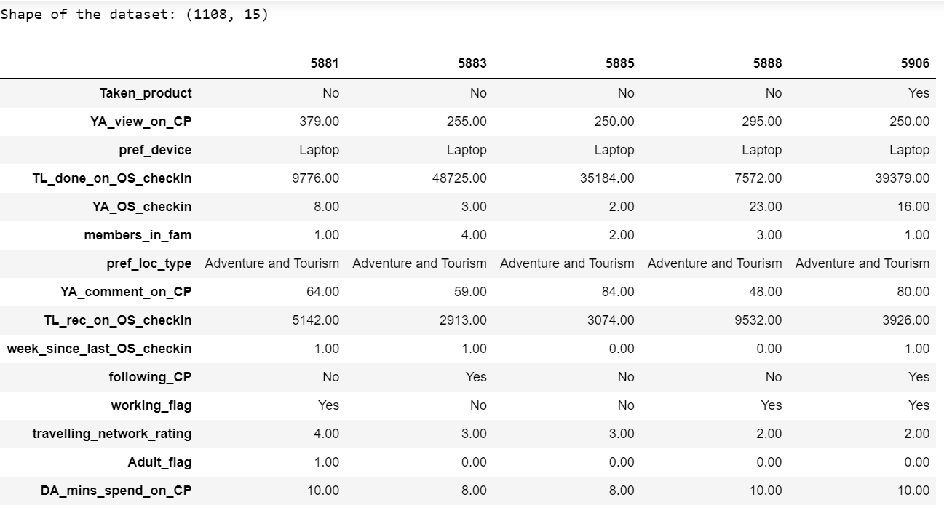

There are total 1108 users who prefer laptop for their use.

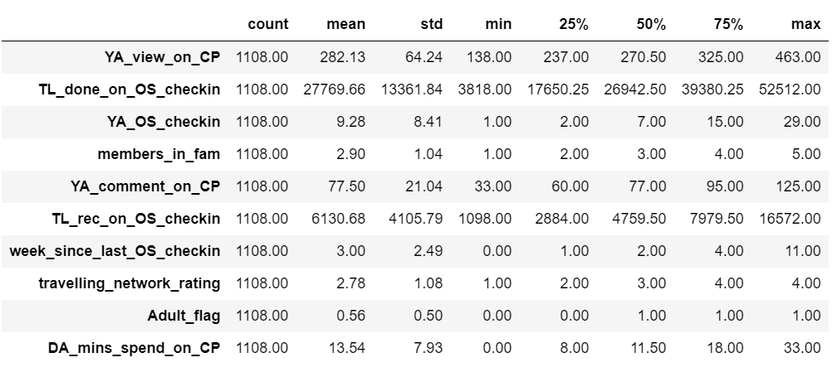

Another one is for Mobile users.

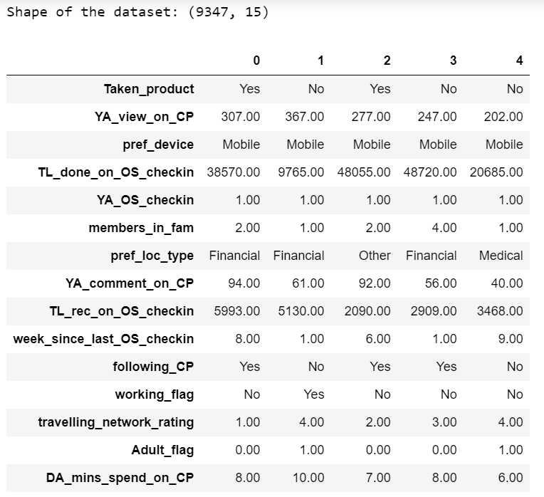

9347 users prefer mobile.

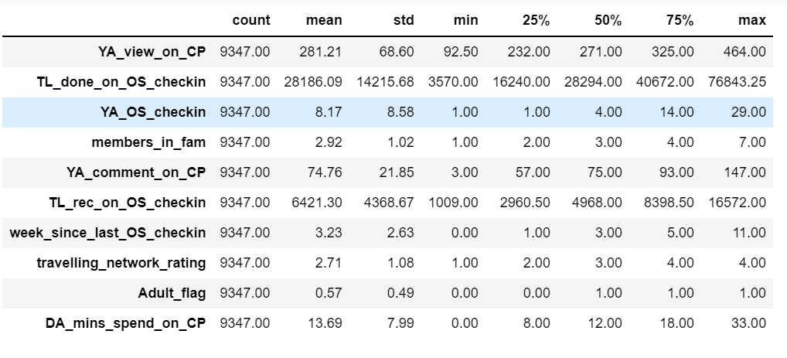

Now we will be doing calculations for our model building. So for that we need to first encode the categorical data from both the data sets.

For encoding, we will be using one-hot encoding method since there are limited number of categories.

Below is the data head after applying the one-hot encoding on laptop data.

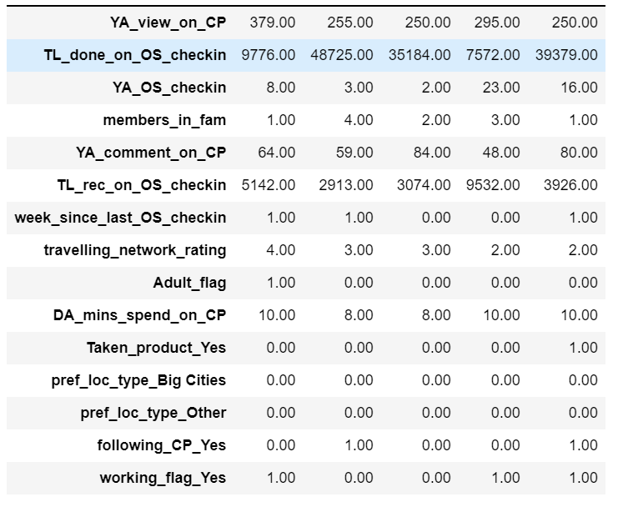

Here categorical variables has now encoded and separated with a different columns as seen above.

Preferred location type, following company page, taken product, variables have been encoded to numerical values.

Below is the data set for mobile users after encoding.

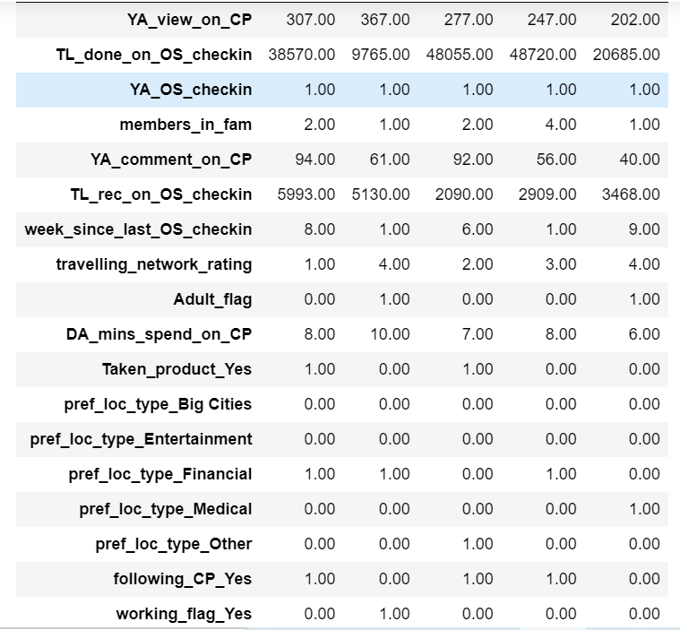

Here also all the categorical variables has encoded and separated with a different column as seen above.

Preferred location type, following company page, taken product, variables have been encoded to numerical values.

Taken product is the target variable.

Calculations for Model Building: For Laptop users:

Train-Test split:

After separated the dependent and independent variables from the data, I have split the data into train and test set in 70:30 ratio.

69.95% of the data is training data.
30.05% of the data is testing data.

X_train is the training data. It has 775 rows.
X_test is the testing data and it has 333 rows.

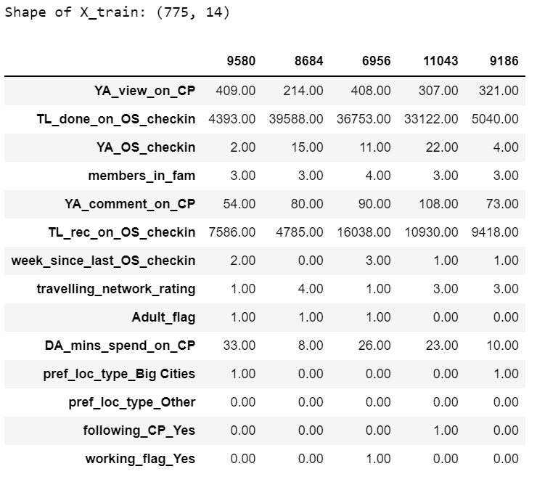
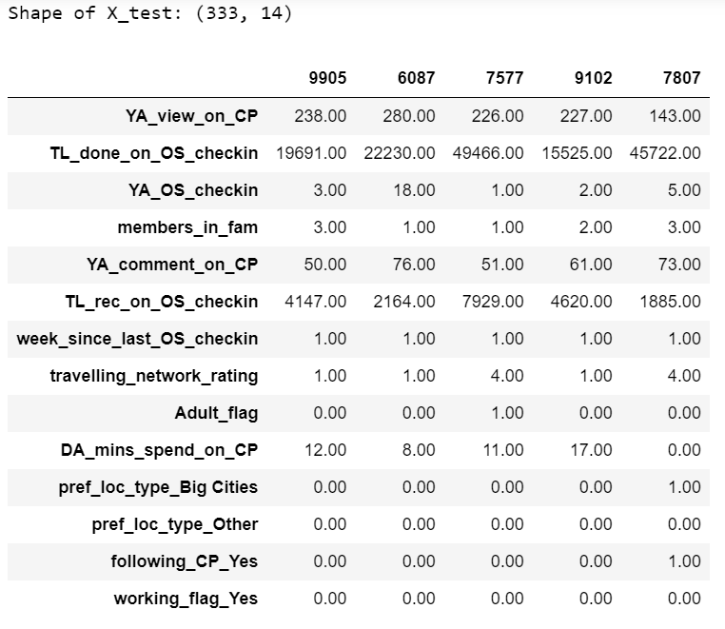

Normalization:

Normalization of the training data and testing data has been done separately using standard scaler, since there are few variables with higher magnitude and few with very low magnitude.

‘normalized_X_train’ = Training data after normalization
‘normalized_X_test’ = Testing data after normalization

Need of applying SMOTE (Oversampling):

As per our analysis, we got to know that the data is more towards the negative side, like majority of the users have not taken our product. This clearly means that data is in imbalance state.
The values in the target variable ‘Taken Product’ are 1 and 0.
1 means user has taken the product and 0 means user has not taken the product.

Out of 1108 laptop users, 832 laptop users has not taken the product and only 276 users has taken the product. This means that there is class balance imbalance in the dataset, where 1 is minority class and 0 is in majority class.

Standard ML techniques such as Decision Tree and Logistic Regression have a bias towards the majority class, and they tend to ignore the minority class. They tend only to predict the majority class, hence, having major misclassification of the minority class in comparison with the majority class. In more technical words, if we have imbalanced data distribution in our dataset then our model becomes more prone to the case when minority class has negligible or very lesser recall.

So, to overcome this problem of imbalance data, a technique called SMOTE need to apply.

First we will build the logistic regression model without handling the imbalance data and will check the results and other metrics.

Logistic Regression Model (with default values): On imbalance data:

Below steps have been performed and tested the model performance on test data:

Imported the logistic regression from sklearn library.
Fit that model into train data.
Predict the model performance on train and test data.
Check the accuracy on train data.

Accuracy on training data: 0.8490322580645161, around 85%, but accuracy is not a good predictor here for such classification algorithms where the number of classes are very less. Let’s look at the other measures as well.
Classification Report for training data:

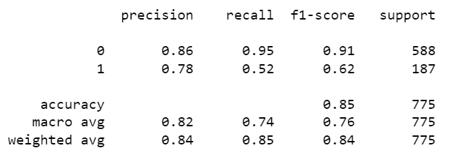

Classification Report for testing data:

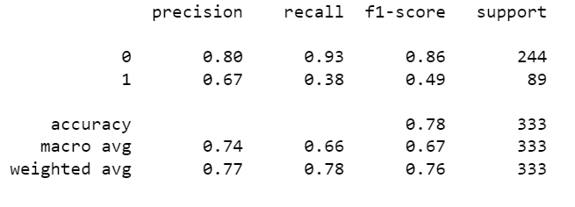

We can clearly see that the accuracy comes out to be 78% in test data and 85% in train data, but, the recall of the minority class in very less (38%).

It means that the model is more biased towards majority class. So, it proves that this is not the best model, and it might be because of class imbalance.

Now, let’s apply SMOTE for oversampling and again build the model to check its performance after balancing the data.

Below steps performed for oversampling:

Imported SMOTE.
Applied using Fit sample on training data.

After Oversampling, the shape of X_train: (1176, 14)
After Oversampling, the shape of Y_train: (1176, 1)

Logistic Regression Model (with default values): On balanced data - After applying SMOTE – Oversampling:

Now we will make the model again and check the recall values for majority and minority classes.

Below steps have been performed and tested the model performance on test data:

Imported the logistic regression from sklearn library.
Fit that model into train data.
Predict the model performance on train and test data.
Check the accuracy on train data.

Accuracy on training data is around 79%.

Classification Report on training data:

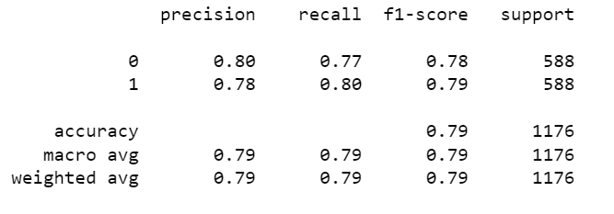

Classification Report on testing data:

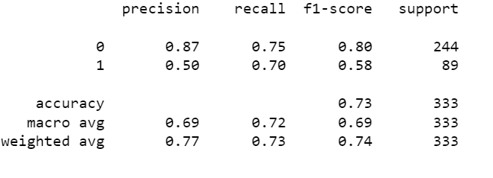

Now the difference is clear, that after over-sampling, the accuracy has been decreased from 85% to 73%.

But as we know that the accuracy is not the good predictor here in our case because we are dealing with less classes and it is also a classification algorithm.

So here we will focus more on improving our recall. Now, the recall for the minority class has been increased a lot, and it is 70%. That is very good. But the recall for the majority class has been decreased, this is due the fact that now that there is a balance in both the classes.

Recall value for the minority class(1) is 0.70 which is a good prediction, since our model has predicted 70% of the 1's as 1's and only 30% of the prediction were wrong.

Logistic Regression Model (Customized Values): On balanced data - After applying SMOTE - Oversampling

As we have built the previous model with its default values. There might be chances of better model than this, with some customized parameters for the logistic regression model.

We can improve the model by tuning the hyper-parameters of the model. So here we will use some custom parameters and then check our model performance.

Below steps have been performed and tested the model performance on test data:

Imported the logistic regression from sklearn library.
Fit that model into train data.
Predict the model performance on train and test data.
Check the accuracy on train data.

Accuracy on training data: 79%

Classification Report for training data:
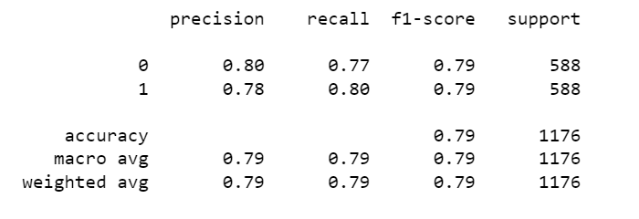

Classification Report on testing data:

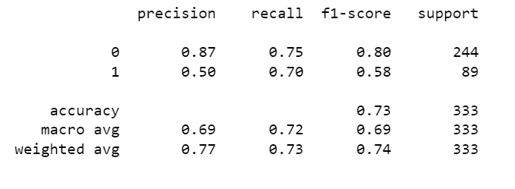

There is not much difference in the matrix using customized parameters.

Confusion Matrix for training data:

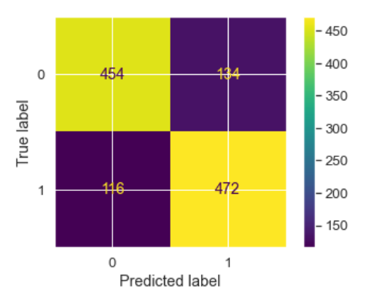
So, True Positives are coming here is 472, that means 472 times our model has predicted correctly, that means it has predicted 1 as 1, and only 116 times it has predicted incorrectly.

Similarly, True Negatives are 454 that means 454 times it has predicted 0 as 0 and only 116 times, the prediction was incorrect.

Confusion Matrix for test data:

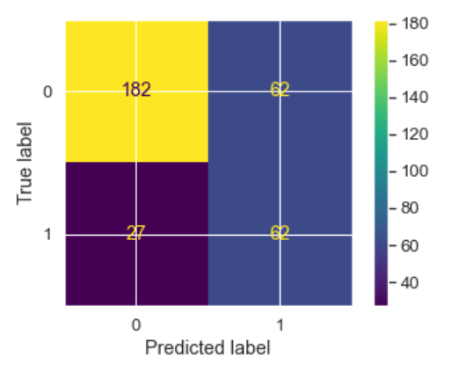

So, in test data, True Positives are coming here is 62, that means 62 times our model has predicted correctly, that means it has predicted 1 as 1, and only 27 times it has predicted incorrectly.

Similarly, True Negatives are 182 that means 182 times it has predicted 0 as 0 and only 62 times, the prediction was incorrect.

AUC Score and ROC curve on train data:

Area under curve: 86%

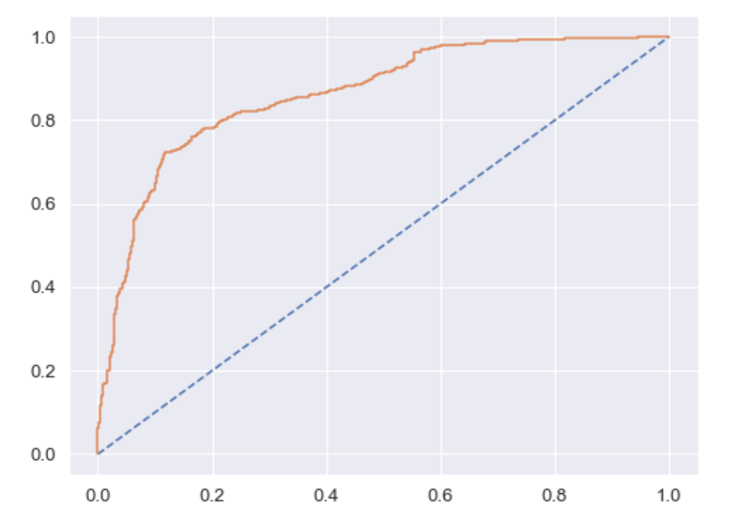

So in the above model, the area under the curve is 86% that means the overall model performance is good.

Also, the confusion matrix and classification report in the LR_SM Logistic Regression Model is giving the good results.

Using GridSearchCV for Logistic Regression:

After apply fit on train data, we got the below best parameters and best estimator for the grid search.

Best Parameters from Grid Search: {'penalty': 'l2', 'solver': 'sag', 'tol': 0.0001}

Best estimator from Grid Search: LogisticRegression (max_iter=10000, n_jobs=2, solver='sag')

Applying the above parameters in logistic regression model and plotting the confusion matrix.

Confusion Matrix on train data:
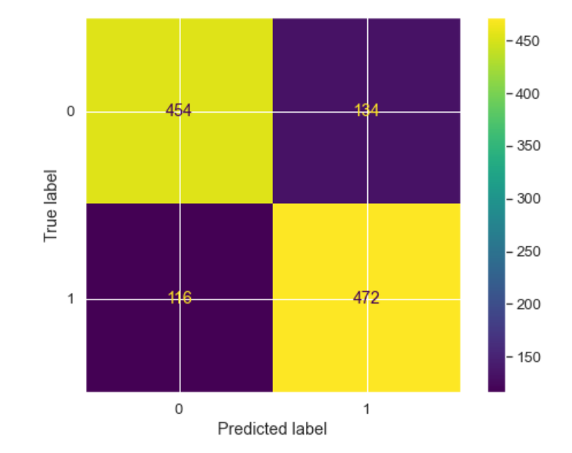

Classification Report for train data:

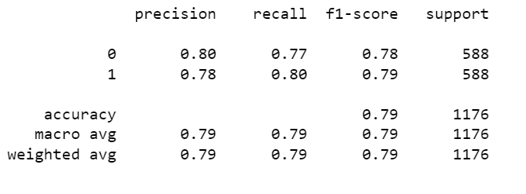

Confusion Matrix for test data:

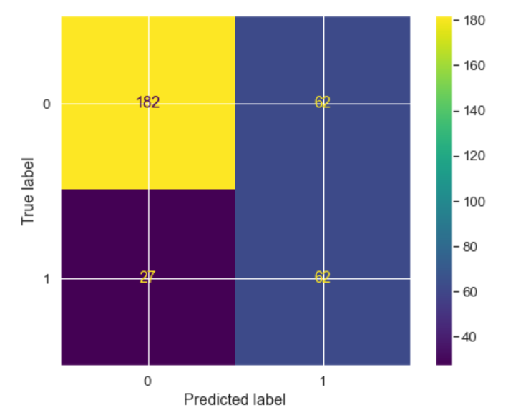
Classification Matrix for test data:

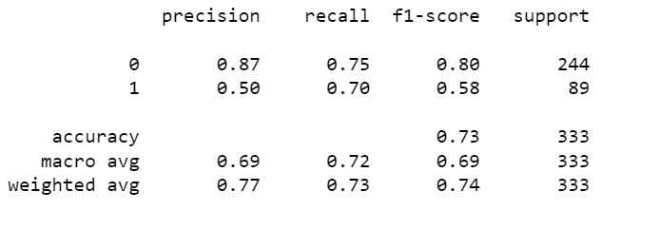

There is no change in the recall values and other matrix as well after using GridSearchCV.

This might not be the best model. We will check other models as well.

KNN Model (k-nearest neighbors)

Below steps are performed to build KNN model:

Imported KNN classifier from sklearn library.
Fit the model on train set.
Predicted the model on train set.
Calculated the accuracy on train set.

KNN model score (accuracy) on train data: 99%

KNN model score (accuracy) on test data: 91%

Classification Report for train data:

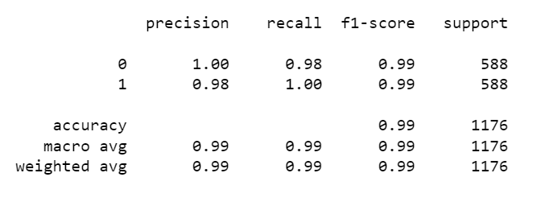

Classification Report for test data:

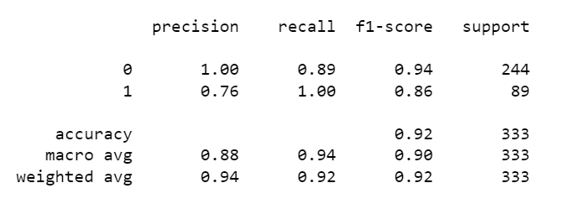

Recall Value is much better than the logistic Regression model.

Recall for the minority class (1) is 80 which is good, and also the accuracy is 79 that is also a good score. Now let's check the AUC ROC Curve and other metrics as well.

Now, we will check for other matrix as well.

Area under curve (AUC): 1

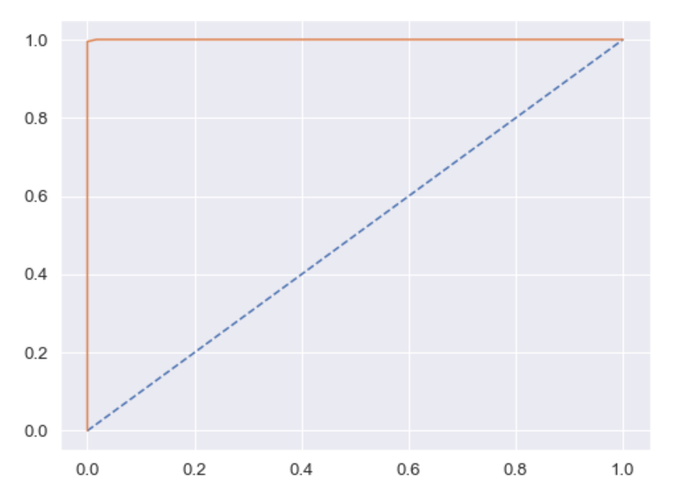

Since, the AUC = 100%, which is too good and it means that the KNN based classifier's performance is better for the model at distinguishing between the positive and negative classes.

Naïve Bayes Model:

Imported GaussianNB and fit the model into train data.

Let see the performance of our model with training data.
Model Accuracy on train data: 0.73
Let see the performance of our model with testing data.
Model Accuracy on test data: 0.70
Confusion Matrix & Classification Report:
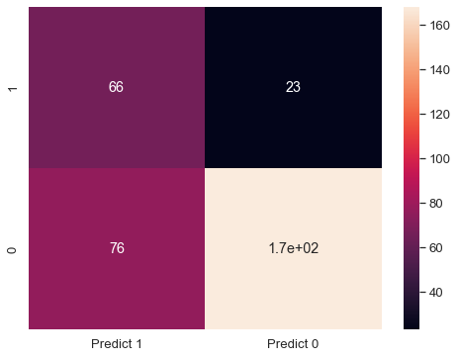

Classification Report:
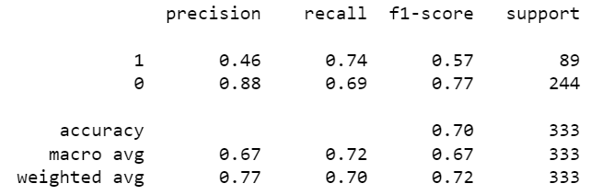
2. Model Tuning
Ensemble modeling, wherever applicable.
Any other model tuning measures (if applicable).
Interpretation of the most optimum model and its implication on the business.

Random Forest:
Out of bag (OOB) score is a way of validating the Random forest model. OOB score is computed as the number of correctly predicted rows from the out of bag sample.
Max_features will be used to select randomly features from the available number of features.
Chosen the below parameters:
Max_depth = 10,
Max_features = 5,
Min_samples_leaf = 50,
Min_samples_split = 110,
N_estimators = 301,
oob_score = True, it will give out of bag score for random forest classifier.
OOB Score: 0.826530612244898
Checking the error rate in %: 1 – OOB Score
Error rate (in %): 0.173469387755102
For the above specified grid parameters, we got the random forest model with OOB score around 83% and error rate 17%, which shows the model is good to go for further evaluation.

Getting the Feature Importance:

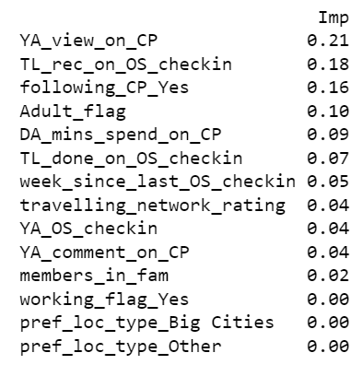

Let's now use Ensemble techniques: Bagging, Ada Boosting, and GradientBoost.
Let's first look by use Bagging. We will be using random forest as base_estimator.
Bagging Classifier accuracy on test data: 73%.
Confusion Matrix:
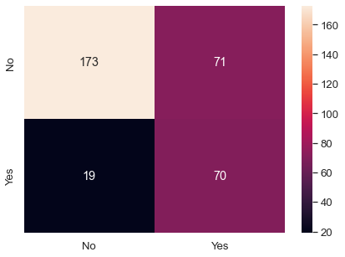

Applying Ada Boosting:

Imported Ada Boosting Classifier.
Fit on the train set and test set.
Accuracy Score is: 45%

Confusion Matrix:
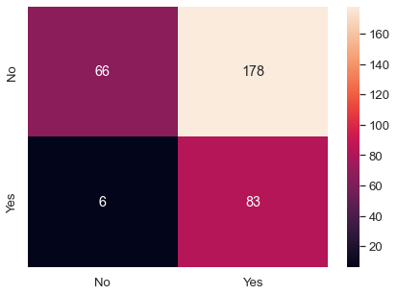

Applying Gradient Boost:

Accuracy on test set is: 61%.

Confusion matrix:

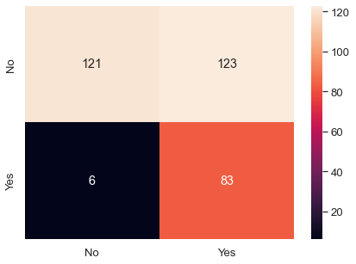

Calculation for Model Building: For Mobile users
Train-Test Split:
Let’s separate dependent and independent variables
Split the data into test and train sets in 70:30 ratio
Shape of x_train: (6542, 17)
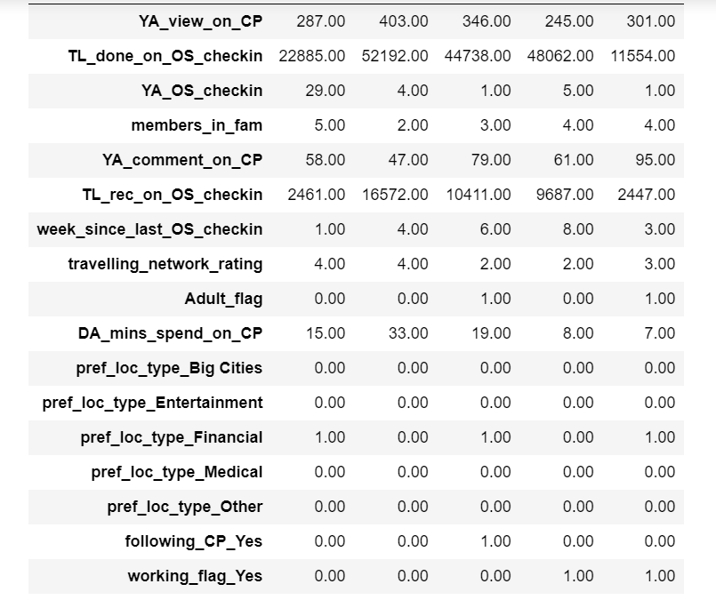

Normalization has been done on test and train set.
Shape of x_test: (2805, 17)
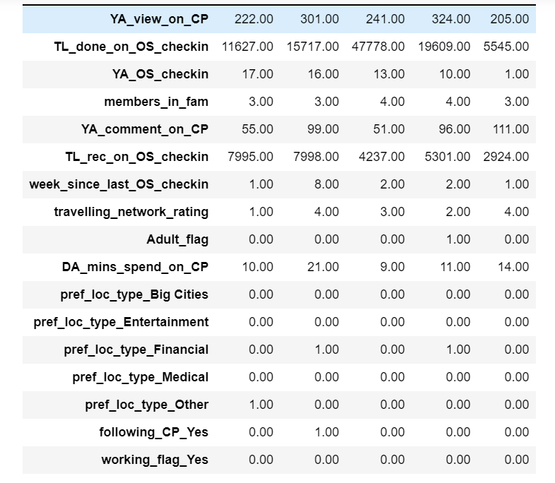
Need of applying SMOTE:
As per our analysis, we got to know that the data is more towards the negative side, like majority of the users have not taken our product. This clearly means that data is in imbalance state.
Standard ML techniques such as Decision Tree and Logistic Regression have a bias towards the majority class, and they tend to ignore the minority class. They tend only to predict the majority class, hence, having major misclassification of the minority class in comparison with the majority class. In more technical words, if we have imbalanced data distribution in our dataset then our model becomes more prone to the case when minority class has negligible or very lesser recall.
So we will be using an over sampling technique called SMOTE to handle imbalanced data.
Logistic Regression Model (with default values): On imbalance data
Let us first now train the data without handling imbalance problem
Model Evaluation - Accuracy on training data
Accuracy on train set: 0.8720574747783553
Classification Report - training data
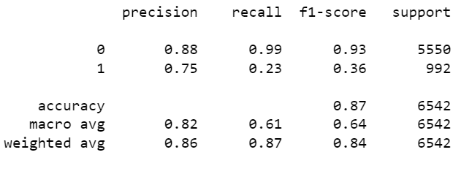

Classification Report - testing data
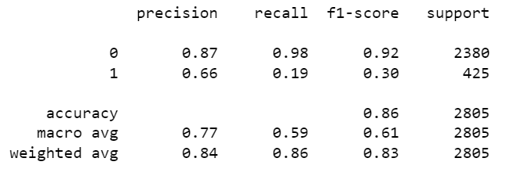
Applying SMOTE:
Now, we will apply the imbalanced data handling technique, called SMOTE and test its accuracy and recall results.
After Oversampling, the shape of x_train: (11100, 17)
After Oversampling, the shape of y_train: (11100, 1)
Logistic Regression Model (with default values): On balanced data - After applying SMOTE - Oversampling
Now we will again make the model again and check the recall values for majority and minority classes.
Now let's fit the model on train data
Model Accuracy on train data: 0.7296396396396396
Classification Report - Train data
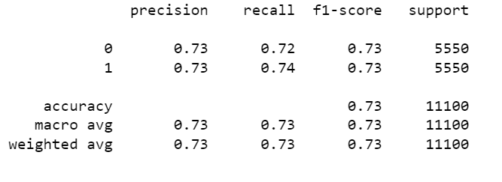

Classification Report - Test data
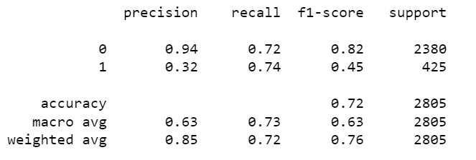
Now the difference is clear, that after over-sampling, the accuracy has been reduced, But as we know that the accuracy is not the good predictor here in our case because we are dealing with less classes and it is also a classification algorithm.
So here we will focus more on improving our recall. Now, the recall for the minority class has been increased a lot, and it is very good. But the recall for the majority class has been decreased, this is due the fact that now that there is a balance in both the classes.

Logistic Regression Model (Customized Values): On balanced data - After applying SMOTE - Oversampling
As we have built the previous model with its default values. There might be chances of better model than this, with some customized parameters for the logistic regression model.
We can improve the model by tuning the hyper-parameters of the model. So here we will use 'GridSearchCV' method to get the best parameters and then we would want to test out in the model again.
Fit the Logistic Regression model
Model Evaluation - Accuracy - for Train data: 0.7296396396396396
Classification Report - Train data
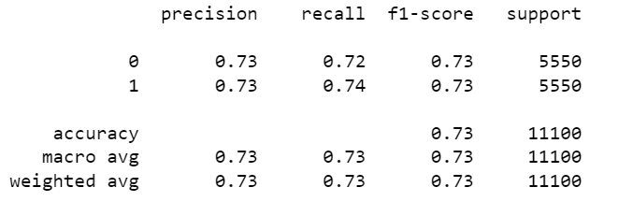
Classification Report - Test data
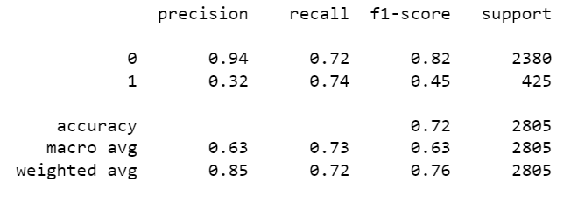
Confusion Matrix, AUC, ROC for the Model:

Confusion matrix - Train data
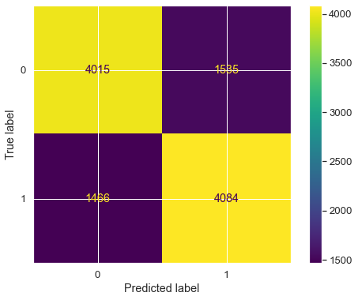
So, True Positives are coming here is 4084, that means 4084 times our model has predicted correctly, that means it has predicted 1 as 1, and only 1466 times it has predicted incorrectly.
Similarly, True Negatives are 4015 that means 4015 times it has predicted 0 as 0 and only 1535 times, the prediction was incorrect.

Confusion matrix - Test data
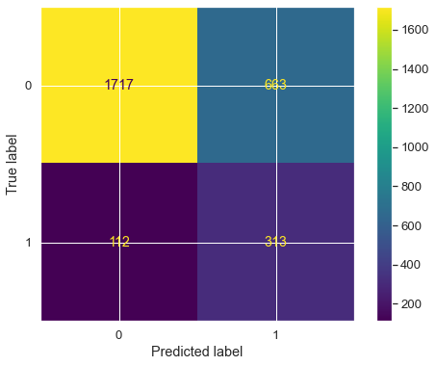
So, in test data, True Positives are coming here is 313, that means 62 times our model has predicted correctly, that means it has predicted 1 as 1, and only 27 times it has predicted incorrectly.
Similarly, True Negatives are 182 that means 182 times it has predicted 0 as 0 and only 62 times, the prediction was incorrect.
Predicting Probabilities and then Calculate Area under curve.
Calculate ROC curve:
Plot the roc curve for the model:
AUC: 0.794
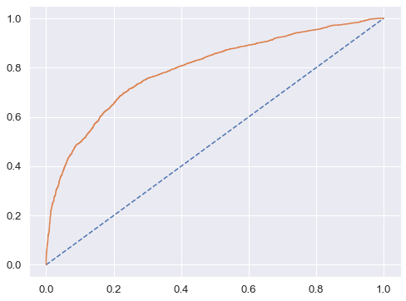
Accuracy score - for Test data: 0.7237076648841355
So in the above model, the area under the curve is 86% that means the overall model performance is good.
Also, the confusion matrix and classification report the LR_mob_SM Logistic Regression Model is giving the good results.
Using GridSearchCV for Logistic Regression.
Prediction - Train data
Confusion Matrix - Train data

Classification Report - Train data
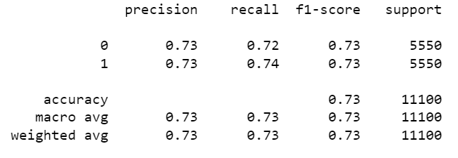
Confusion Matrix - Test data
Classification Report - Test data
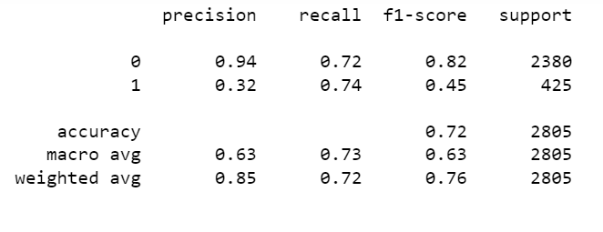
KNN Model (k-nearest neighbors):
We will be building KNN model on re-sampled train sets.
Importing KNeighboursClassifier.
Accuracy on train data: 0.9808108108108108
Classification Report & Confusion Matrix:

Classification Report:
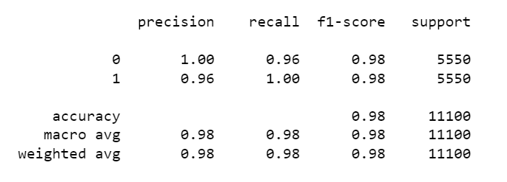

AUC ROC Curve on Train data:

Area under curve: 1.000 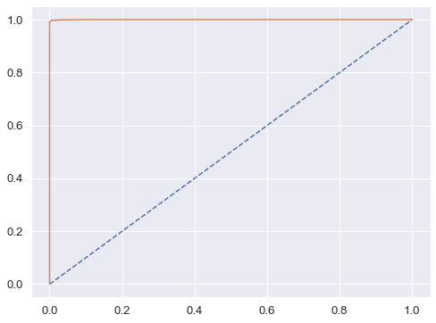

Naive Bayes Model:

Model Accuracy on train data: 0.69
Model Accuracy on test data: 0.66
Confusion Matrix:

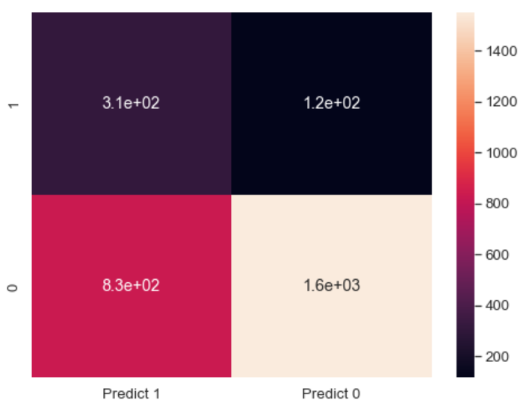
Classification Report:
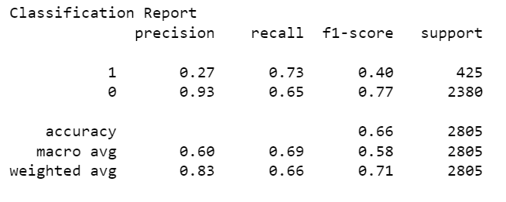
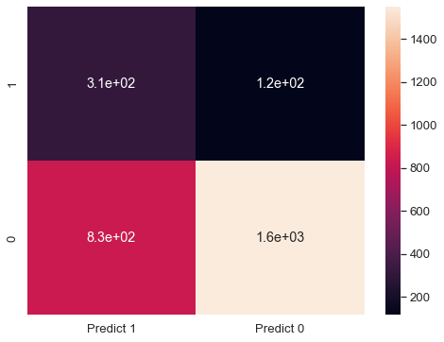
2. Model Tuning
Ensemble modeling, wherever applicable.
Any other model tuning measures (if applicable).
Interpretation of the most optimum model and its implication on the business.
Random Forest:
Out of bag (OOB) score is a way of validating the Random forest model. OOB score is computed as the number of correctly predicted rows from the out of bag sample.
Max_features will be used to select randomly features from the available number of features.
rfcl_mob
rfcl_mob.oob_score_ = 0.8774774774774775
Checking the error rate in %:
OOB Error is the number of wrongly classifying the OOB Sample.
Error rate (in %): 0.12252252252252249
For the above specified grid parameters, we got the rfcl_mob model with oob score around 83% and error rate 17%, which shows the model is good to go for further evaluation.

Feature Importance:
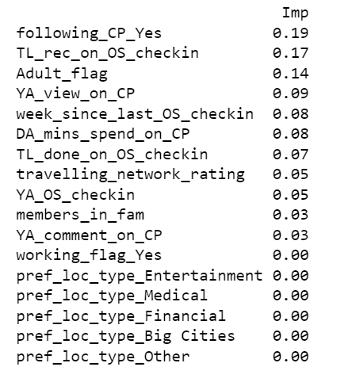
Let's now use Ensemble techniques: Bagging, Ada Boosting, and GradientBoost:
Let’s first look by use bagging. We will be using random forest as base_estimator
Model Accuracy on test set: 0.8156862745098039
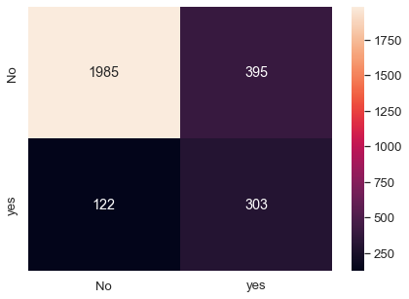
Ada Boosting:

Prediction on - Test data
Accuracy on test data: 0.6880570409982175

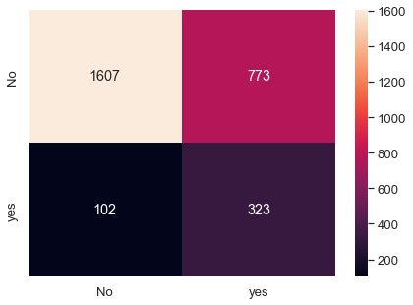

Gradient Boost:

Accuracy on test set: 0.5572192513368984

